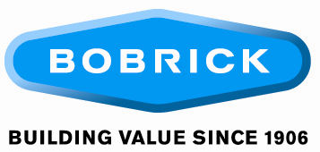
Position: Manufacturing Associate/Partitions Finisher
Location: North Hollywood, California

Job Responsibilities
- Work closely with other department members in a fast paced environment.
- Handle phenolic and laminate material to finish and drill components.
- Operate and perform general maintenance on machines and equipment regularly.
- Use a variety of material handling equipment, including forklifts, as needed.
- Maintains production and quality standards.
- Reports, and contributes to problem solving in order to correct or prevent quality defects and errors.
- Assists senior level department positions in packaging, gluing and finishing components.
- Loads, unloads and organizes materials in the department as required.
- Uses drills and fixtures to attach leveling devices, t-nuts, and inserts.
- Prepares headrails for shipment as required.
- Submits suggestions for departmental, process and safety improvements.
- Maintains work area in a neat and orderly manner.
- Works in accordance with all safety standards.
- Uses a variety of material handling equipment, including forklifts as needed.
- Utilizes RF Scanners to scan labels and track job information.
- Under close supervision, checks toilet compartment components for final finish and appearances, and files out blemishes or scratches to ensure quality standards.

Minimum Requirements
- High school diploma or general education degree (GED).
- Some shop or industrial woodworking experience preferred.
- Ability to read, write and follow verbal and written instructions in English.
- Must possess basic math skills.
- Must be able to read a tape measure.
- Capable of using routers, files and other shop equipment as directed and trained.
- Must be able to organize own work and determine sequences of operations.

